Seasonal Adjustment With X-13ARIMA-SEATS

Worksheet 2 – Moving Average Filters

What are the advantages of using various filters? That is, when would we prefer a 3x3 seasonal filter to a 3x5? Why would we want to use a 3x9 filter?

Below are some graphs of filter weights:

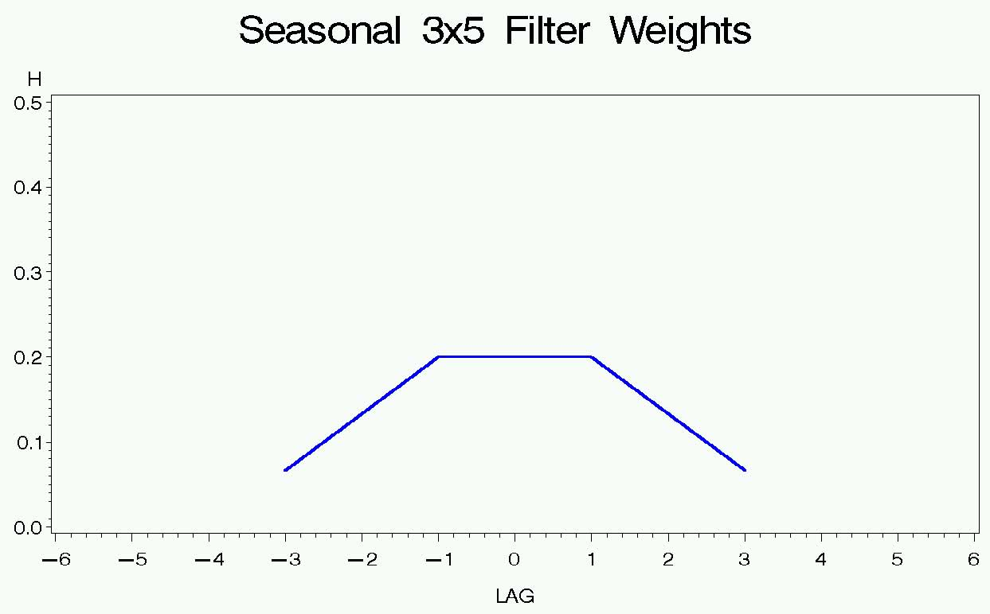

What would the weights look like for a 3x1 filter? The 3x3 filter? The 3x9 filter?

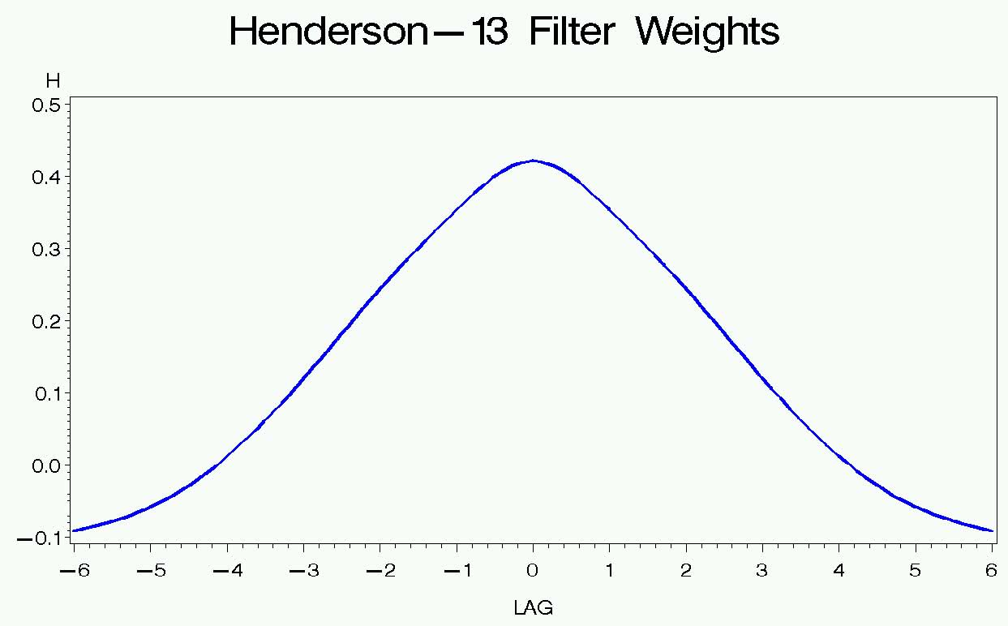

Will a Henderson-23 filter be flatter or more peaked than the Henderson-13 filter?